SIMATS ENGINEERING
ASSESSMENT TOOL 1

COURSE NAME: Artificial Intelligence COURSE CODE: CSA17

COURSE OUTCOME COVERED

CO1: Apply AI basics such as intelligent agents and uninformed search methods to solve problems effectively. (BL3)

Assessment Tool Weightage: 50%

QUESTIONS: 5 Duration : 1 Hour
Total Marks: 50

Annexure A
Analytical Problem Solving

Code of Conduct:

I Yash Pandey / 192573028 (Name / Reg No) certify that this submission is my original work and that I have adhered to the guidelines specified for this assessment.
I understand that any violation of academic integrity rules will result in disciplinary action.

Signature of the student: Yash Pandey

Annexure A
Analytical Problem Solving

1. Solve the Water Jug problem: you are given 2 jugs, a 4-gallon one and 3-gallon one. Neither has any measuring maker on it. There is a pump that can be used to fill the jugs with water. How can you get exactly 2 gallons of water into 4-gallon jug?
Explicit assumptions: A jug can be filled from the pump, water can be poured out of a jug onto the ground, water can be poured from one jug to another and that there are no other measuring devices available.

2. Find out how Mars Rover, analyse and explore the samples on Mars by answering the following questions.
i. What are the percept's for this agent?
ii. Characterize the operating environment.
iii. What are the actions the agent can take?
iv. How can one evaluate the performance of the agent?
v. What sort of agent architecture do you think is most suitable for this agent? Why?

3. Explore the search space using search strategies and formulate the problem components for the 8-Queens problem using the following information: Place 8 queens on a chessboard such that none of the queen's attack any of the others. A configuration of 8 queens on the board as shown in the figure below, but this does not represent a solution as the queen in the first column is on the same diagonal as the queen in the last column.

4. A customer wants to travel from the one location to another location using OLA Cab booking mobile application. The customer can select the any of the cab type as mini, micro, sedan, shared, prime and so on based on his comfort to reach the destination. Identify what type of problem-solving agent can be used and write the pseudocode for the above problem.

5. A logistics company operates a delivery network where packages must be transported between warehouses at minimum cost. Each route between warehouses has an associated travel cost (fuel + time). The company wants to determine the least-cost path from the starting warehouse S to the destination warehouse G using the Uniform Cost Search (UCS) algorithm.
The delivery network is represented as a weighted graph:

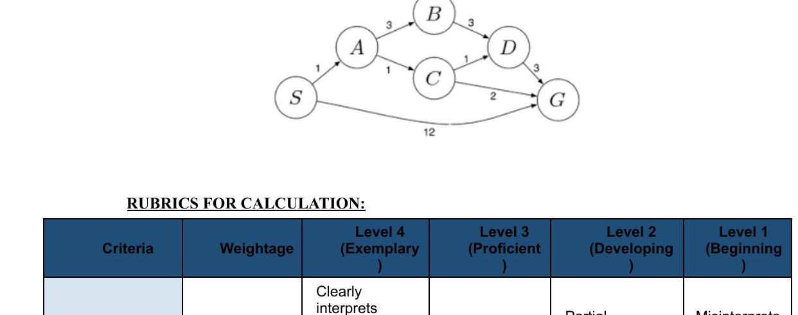

RUBRICS FOR CALCULATION:

Criteria | Weightage | Level 4 (Exemplary) | Level 3 (Proficient) | Level 2 (Developing) | Level 1 (Beginning)
Problem Understanding | 20% | Clearly interprets problem, identifies all parameters and requirements accurately | Understands problem with minor gaps | Partial understanding; misses key elements | Misinterprets or unable to understand problem
Method Selection | 20% | Selects most appropriate method/formula with strong justification | Selects correct method with minor errors | Inappropriate or partially correct method | Unable to select method
Solution Process | 25% | Logical, systematic steps with correct approach throughout | Mostly correct steps with minor mistakes | Disorganized steps; multiple errors | No clear process
Accuracy of Calculation | 20% | All calculations accurate; correct final answer | Minor calculation errors | Frequent errors; incorrect final answer | No valid calculations
Interpretation of Results | 15% | Clearly interprets results with units and engineering relevance | Basic interpretation with minor omissions | Limited or unclear interpretation | No interpretation
Problem Understanding | 20% | Clearly interprets problem, identifies all parameters and requirements accurately | Understands problem with minor gaps | Partial understanding; misses key elements | Misinterprets or unable to understand problem

Annexure A
Analytical Problem Solving - Answers

1. Water Jug Problem

Given: a 4-gallon jug and a 3-gallon jug, neither marked. Goal: measure exactly 2 gallons into the 4-gallon jug.

State representation: (x, y) where x = amount of water in the 4-gallon jug, y = amount of water in the 3-gallon jug.

Step | Action | 4-gallon jug | 3-gallon jug
0 | Initial state | 0 | 0
1 | Fill the 3-gallon jug from the pump | 0 | 3
2 | Pour water from 3-gallon jug into 4-gallon jug | 3 | 0
3 | Fill the 3-gallon jug again from the pump | 3 | 3
4 | Pour from 3-gallon jug into 4-gallon jug until it is full (4-gallon jug can take only 1 more litre) | 4 | 2
5 | Empty the 4-gallon jug completely on the ground | 0 | 2
6 | Pour the remaining 2 gallons from the 3-gallon jug into the 4-gallon jug | 2 | 0

Result: after step 6, the 4-gallon jug contains exactly 2 gallons of water, which is the goal state.

2. Mars Rover as an Intelligent Agent

i. Percepts of the agent
- Images and video captured by onboard cameras (navigation and panoramic cameras)
- Readings from spectrometers and sensors that identify soil, rock, and mineral composition
- Position and orientation data from GPS/inertial navigation and wheel odometry
- Obstacle and terrain data from proximity and hazard-avoidance sensors
- Atmospheric readings such as temperature, wind, radiation levels
- Internal state percepts such as battery/power level and instrument status

ii. Characterization of the operating environment
- Partially observable - the rover can only sense the terrain within its sensor range, not the whole planet surface
- Stochastic - outcomes of actions (e.g., wheel slip on sand) are not fully predictable
- Sequential - current decisions (e.g., which path to take) affect future percepts and actions
- Dynamic to semi-dynamic - weather, lighting and dust conditions change over time even without the rover's action
- Continuous - terrain position, angles and sensor values are continuous quantities
- Unknown - the exact terrain layout is not known in advance and is discovered through exploration
- Single-agent - the rover operates independently, without competing or cooperating agents on Mars

iii. Actions the agent can take
- Move forward, reverse, or turn the wheels to navigate the terrain
- Capture images using onboard cameras
- Extend the robotic arm to drill and collect rock or soil samples
- Operate onboard instruments to analyse collected samples
- Avoid or navigate around detected obstacles
- Transmit collected data and images back to mission control on Earth
- Adjust solar panel orientation or enter low-power/sleep mode to conserve energy

iv. Evaluating the performance of the agent
- Number and scientific quality of samples successfully collected and analysed
- Accuracy and usefulness of the terrain maps and data sent back to Earth
- Distance covered safely without damage or getting stuck
- Efficient use of battery power and onboard resources
- Time taken to complete assigned exploration goals
- Reliability of communication with mission control

v. Most suitable agent architecture
A model-based, goal/utility-based learning agent is most suitable. Because the environment is only partially observable, the rover must maintain an internal model of the terrain built from past percepts. Since it must choose among competing objectives (which sample to collect, which path minimises risk and time), a utility-based approach is required rather than a simple reflex response. Finally, because Mars terrain is unknown and conditions change, a learning component lets the rover improve its navigation and decision-making from experience over the course of the mission.

3. Problem Formulation for the 8-Queens Problem

The 8-Queens problem asks for a placement of 8 queens on an 8x8 chessboard such that no two queens attack each other (no shared row, column, or diagonal). The problem is formulated using the incremental formulation below, which places one queen per column and is far more efficient than a complete-state formulation.

- State: Any arrangement of 0 to 8 queens on the board, with at most one queen per column, and no queen already attacking another.
- Initial state: An empty chessboard with no queens placed.
- Actions: Add a queen to any empty square in the leftmost column that does not yet contain a queen, provided the square is not attacked by any queen already placed.
- Transition model: Returns the board configuration that results from adding the new queen to the specified square.
- Goal test: All 8 queens are placed on the board and no two queens attack one another (no two share a row, column, or diagonal).
- Path cost: Each step costs 1, so path cost equals the number of queens placed; since only the final configuration matters, path cost is not important for this problem.

With this formulation the state space is reduced to only 2,057 possible sequences to check for a solution (compared to about 3 x 10^14 arrangements possible in a naive complete-state formulation), since each new queen is only placed in the next free column and never on an already-attacked square.

Search strategy: this problem is commonly solved using backtracking search, a depth-first search variant. The search places a queen column by column; whenever a placement leads to no valid square in the next column, the search backtracks to the previous column and tries a different row for that queen, continuing until all 8 queens are placed safely.

4. Problem-Solving Agent for OLA Cab Booking

Type of agent: This is best modelled as a goal-based problem-solving agent (specifically a simple problem-solving agent that performs search over possible cab options to reach a well-defined goal state).

Problem formulation:
- Initial state: Customer's current pickup location, with no cab selected.
- Goal state: Customer reaches the destination location in a cab that matches the chosen category (mini, micro, sedan, shared, prime, etc.).
- Actions: Enter pickup and destination, select a cab category, confirm booking, get matched to a driver, ride to destination, make payment.
- Path cost: Combination of fare, estimated travel time, and distance for the selected cab category.

Pseudocode:
BEGIN OLA_Cab_Booking_Agent
INPUT: pickup_location, destination_location
percept <- GET_CUSTOMER_INPUT(pickup_location, destination_location)
available_options <- FETCH_CAB_TYPES(pickup_location)
// e.g. mini, micro, sedan, shared, prime
DISPLAY available_options WITH fare_estimate AND eta TO customer
selected_cab <- WAIT_FOR_CUSTOMER_SELECTION(available_options)
IF selected_cab IS NOT NULL THEN
nearby_drivers <- SEARCH_DRIVERS(pickup_location, selected_cab)
IF nearby_drivers IS NOT EMPTY THEN
driver <- ASSIGN_NEAREST_DRIVER(nearby_drivers)
CONFIRM_BOOKING(driver, pickup_location, destination_location)
route <- COMPUTE_OPTIMAL_ROUTE(pickup_location, destination_location)
TRACK_TRIP(route)
ON_ARRIVAL: PROCESS_PAYMENT(selected_cab, route)
RETURN booking_successful
ELSE
NOTIFY customer("No cabs available, please try again")
END IF
ELSE
NOTIFY customer("Booking cancelled")
END IF
END

5. Uniform Cost Search for the Logistics Delivery Network

Graph edges (from the given figure): S-A = 1, A-B = 3, A-C = 1, B-D = 3, C-D = 1, C-G = 2, D-G = 3, S-G = 12.

Uniform Cost Search always expands the node in the frontier with the lowest cumulative path cost g(n) from the start node S.

Step | Node expanded | Frontier (path : cumulative cost)
1 | S | S-A : 1
2 | A | S-A-C : 2, S-A-B : 4
3 | C | S-A-C-D : 3, S-A-C-G : 4, S-A-B : 4
4 | D | S-A-C-G : 4, S-A-B : 4, S-A-C-D-G : 6
5 | G (goal reached) | Goal test succeeds on S-A-C-G with cost 4

Least-cost path: S -> A -> C -> G
Total minimum cost: 1 + 1 + 2 = 4 units

Interpretation: although the direct edge S-G costs 12 and looks tempting to rule out early, UCS correctly finds that routing the shipment through warehouses A and C costs only 4 units (fuel + time), which is the true least-cost delivery route from S to G. Other candidate routes, S-A-C-D-G (cost 6) and S-A-B-D-G (cost 7), are both higher and therefore rejected in favour of S-A-C-G.

